User Guide 44 Performing Internal Requests
Purpose of this User Guide
The purpose of this User Guide is to explain the key SPEAR screens or tabs that a user has access to in SPEAR when viewing an application.
Who should read this?
Primary audience: All SPEAR users.
Introduction
SPEAR users can request other users within their organisation to perform a specific task in SPEAR. This is done via the optional action ‘Perform Internal Request’.
The recipient, task and due date are set by the requester, with the recipient being notified via email. An email reminder will be sent to the recipient if the action has not been completed 7 days after the date specified by the requester.
Internal requests can be sent to an existing regular SPEAR user or an ‘Access Limited’ user. If an Access Limited user logs into SPEAR, they will only be able to view those applications for which they have been sent an internal request and will only be able to complete the tasks they have been assigned.
Once the application is deemed completed in SPEAR, ‘Perform Internal Request’ will no longer be available.

44.1 How do I perform an internal request?
- On the Details Tab, select ‘Perform Internal Request’ from the ‘Optional Actions’ drop-down list and click ‘go’.
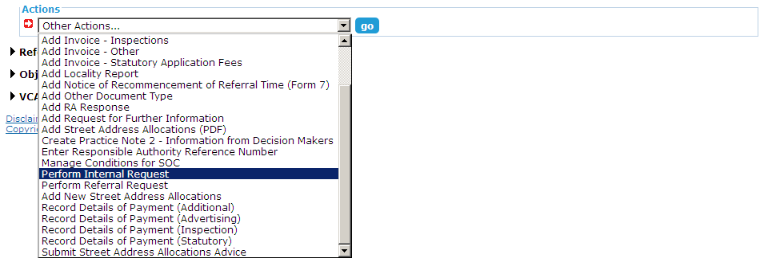

- The Perform Internal Request screen is displayed. Select a user within your organisation from the ‘Recipient’ drop-down list and enter a ‘Subject’ name for the request. Optional comments can be added if required.
- Select the task you require to be performed from the ‘Action’ drop-down list and click the calendar icon to select the date a response is required by. You can add additional actions if required before clicking ‘notify’.
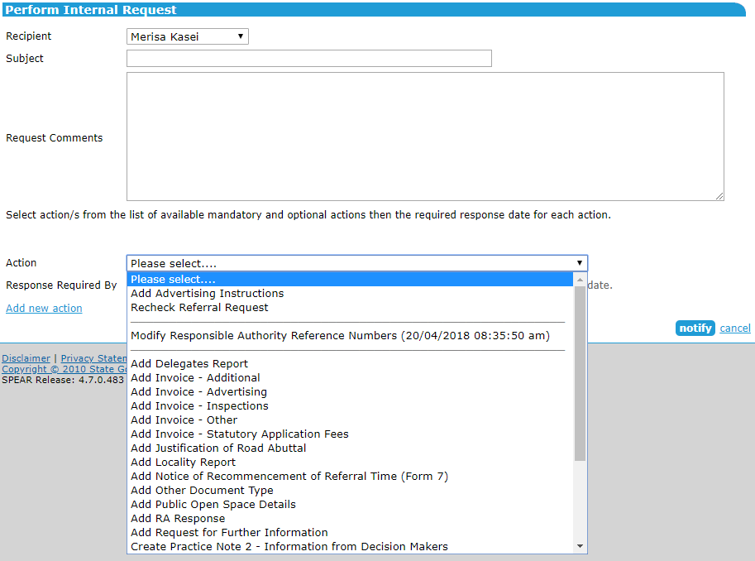
- You will be returned to the Details Tab, from where the internal request action will require authentication.
- Once the internal request is authenticated, the recipient will receive an email notification and will be able to login to SPEAR to complete the assigned task. If the task has not been completed 7 days after the date specified by the requester, the recipient will receive a final email reminder.

44.2 How does the recipient complete the internal request?
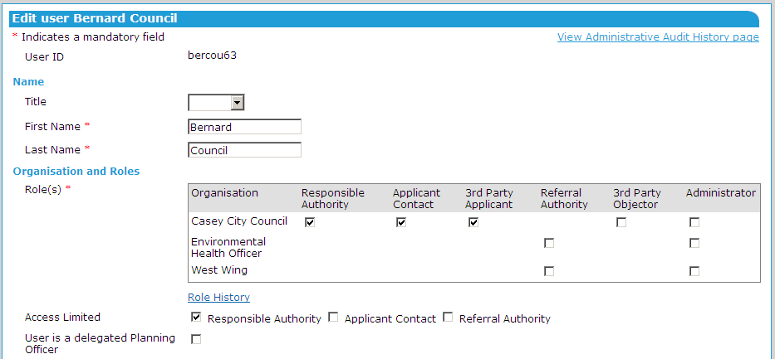
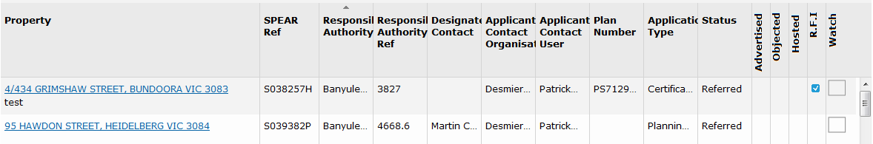
- To complete an internal request you will need to login to SPEAR. If you are an Access Limited user, you will only see those applications for which you have been sent an internal request. Click on the property address to open the required application.

- Browse to the Details Tab and complete the action which you have been requested to perform. Limited Access users will only be able to perform the actions that have been requested via the internal request.
- If you have not completed the action 7 days after the date specified by the requester, you will receive a final email reminder.

44.3 How do I create an Access Limited user?
- Only a SPEAR Administrator or your organisation’s Local Administrator can create an Access Limited user. Both new and existing SPEAR users can be set up as Access Limited users.
- On the Edit User screen, select the ‘Access Limited (Responsible Authority)’ checkbox and click ‘update user’. You will be asked to enter your SPEAR password to confirm the changes.
NOTE: A user cannot be a Delegated Planning Officer and an Access Limited user
at the same time.

- If an existing user becomes Access Limited, he or she will lose access to all SPEAR applications except those for which he or she has been sent an internal request.

Need more information?
Further information on this topic can be found by:
- Visiting the SPEAR website www.spear.land.vic.gov.au/SPEAR
- Contacting the SPEAR Service Desk on 9194 0612 or email spear.info@delwp.vic.gov.au
- Selecting the Help link in the relevant area of the system.

